TECHNICAL PRACTICE:

BI reports:

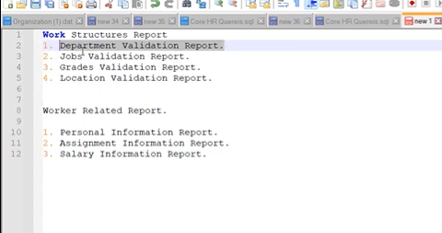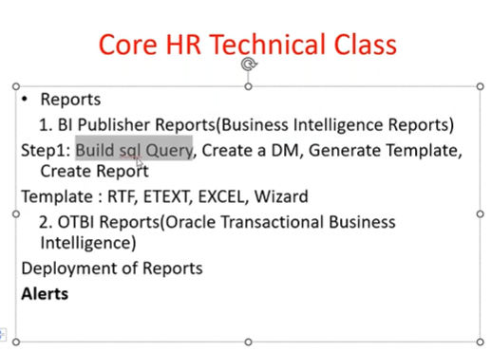

Workstructure report like department validation report, job validation report, grades validation report, location validation report.

Worker related report – personal information report, assignment validation report, salary information report.

1. Department validation report:

Department name, effective start date, effective end date, set_id, status – columns

Select * from per_departments.

🡪Tools – reports and analytics-browse catalog- create data model – save as sample data – save button (shared folder)

Build sql query.

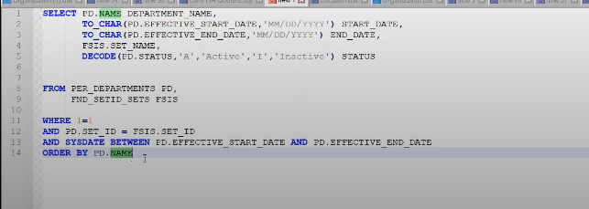

* Create report and choose data model
* Generate template, save the report.

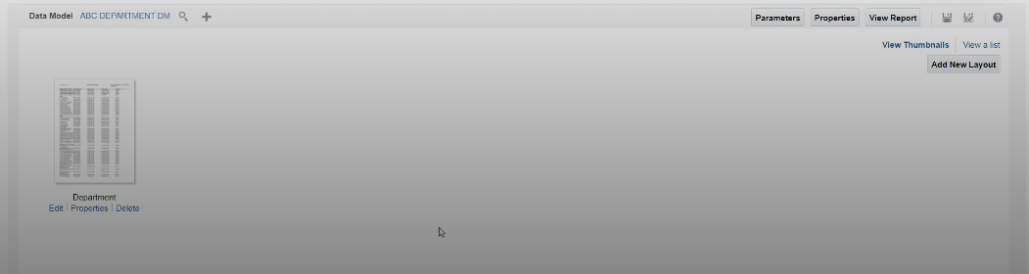

Click on view report. And to download the report.

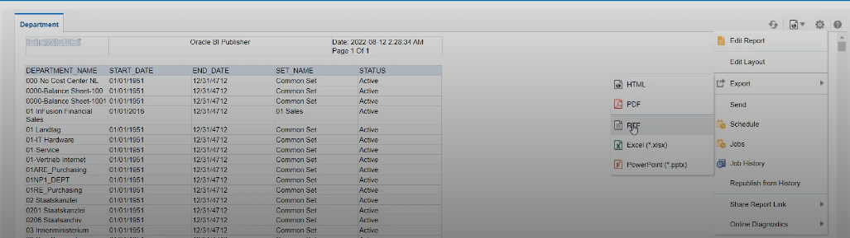

* Modify the template:

Requirement is to change the columns: start date, end date, DPT name, set, status. And Header

Click on action button – click on edit report – the format of the template is RTF.

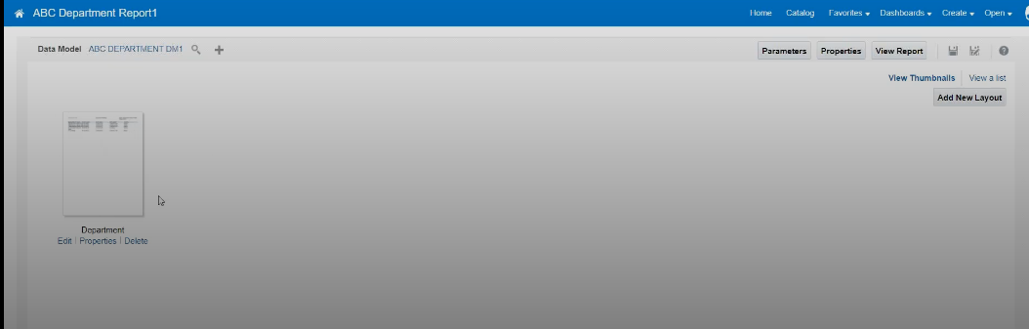

Click on edit button then template gets downloaded.

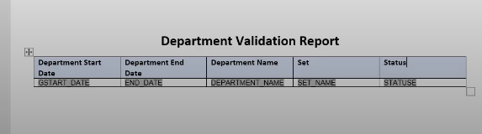

Delete the existing report – click on add new layout

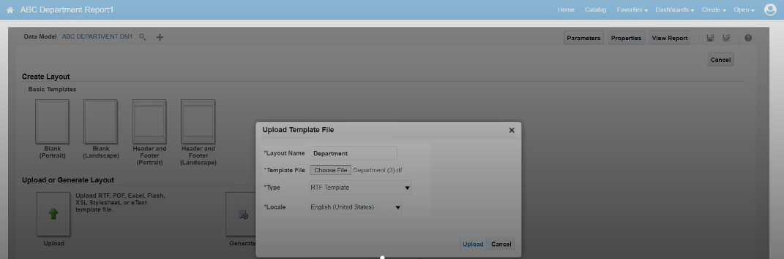

Upload rtf template.

🡪if the client requested to add another column then

Click on edit report – select the data model – edit the sql query,

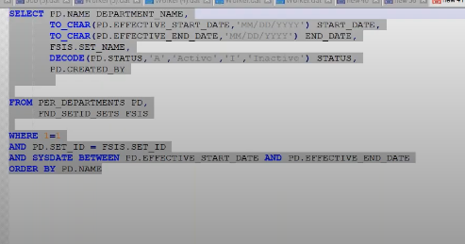

Copy tag name of the column – edit the template – insert column to template – provide tag name – save the template

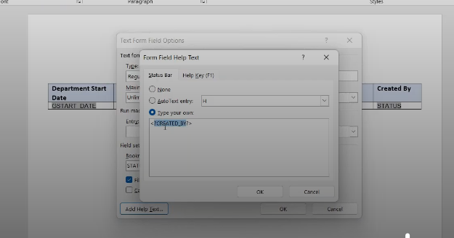

Delete existing template – add new layout – upload

🡪Add Parameters:

Click on edit report – choose data model – add parameter in sql query

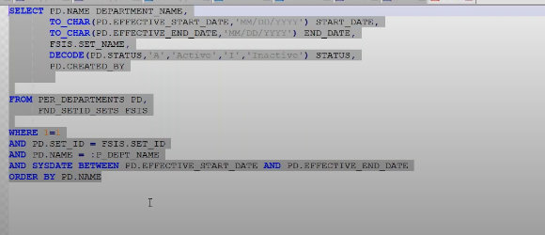

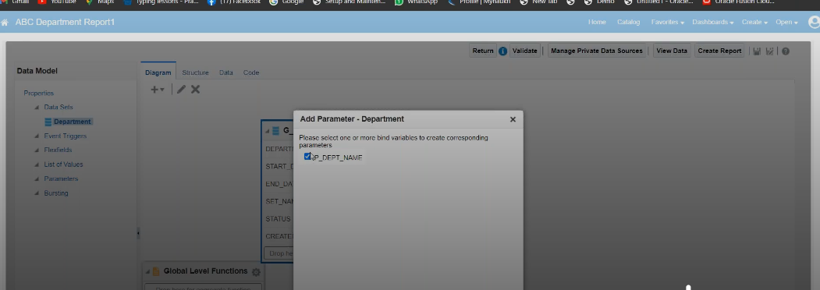

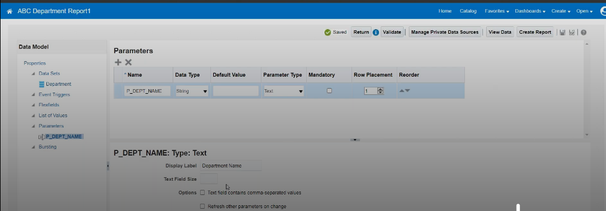

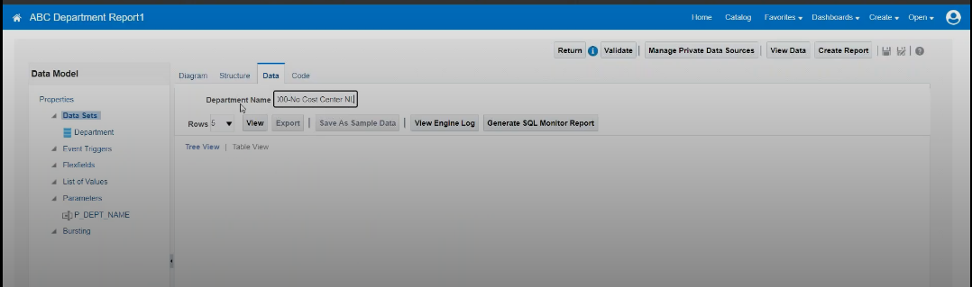

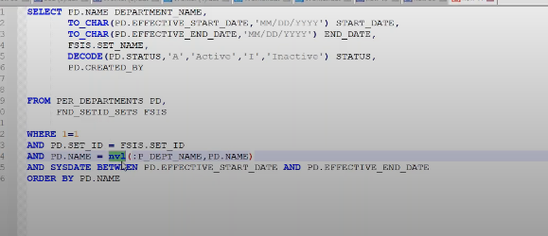

If dept name is null then consider all dpt names.

Even we can have parameters in view report.

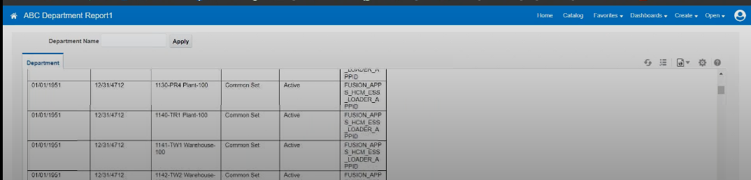

Class-31:

🡪We can create list of values for the parameters

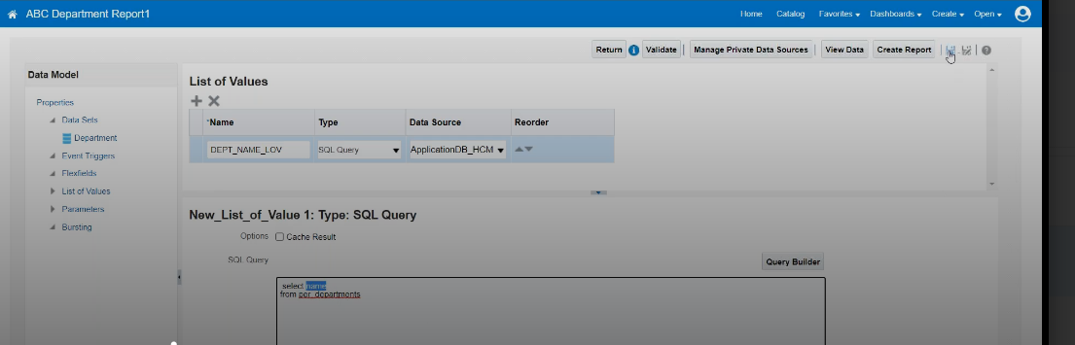

Save. Now we have created list of values.

Go to parameters-select list of values name

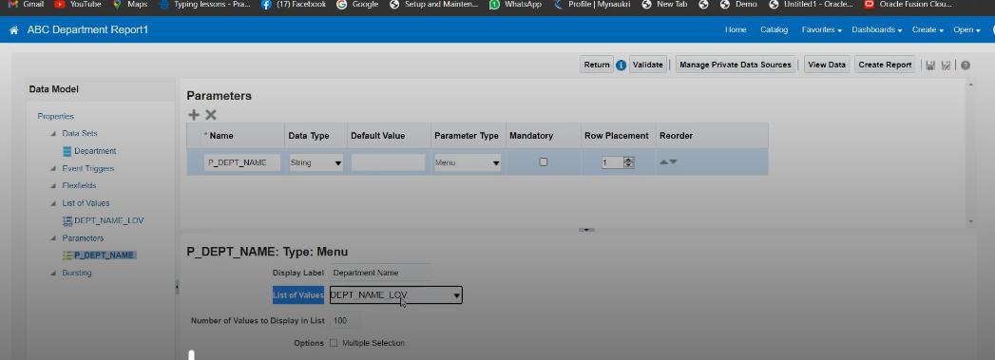

View report –

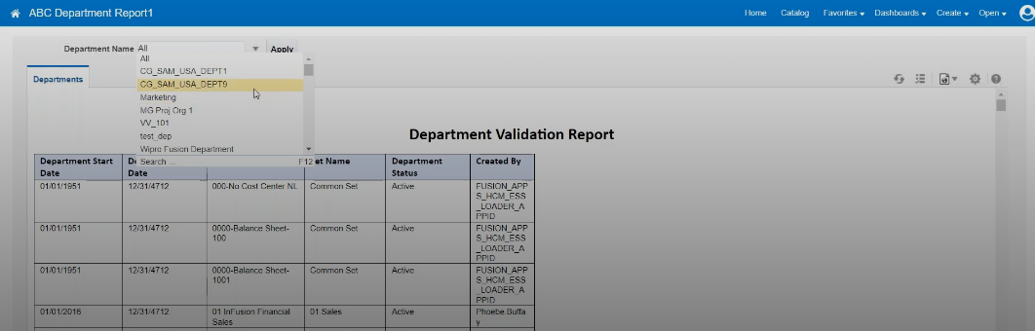

We can create one more parameter.

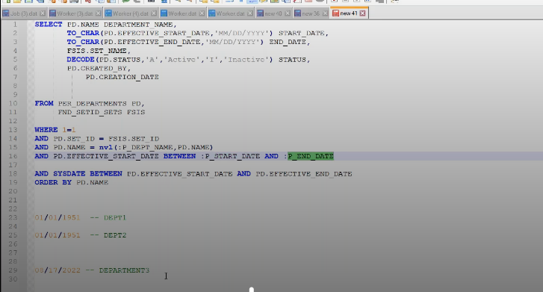

Till now we learnt RTF template. Let’s learn ETEXT template.

🡪sample query to display the employee details

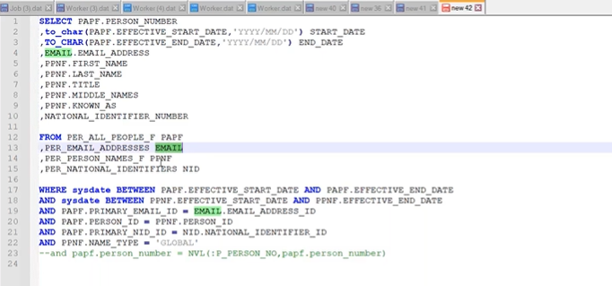

Click on catalog – create data model – use SQL query – save as sample data – click on save

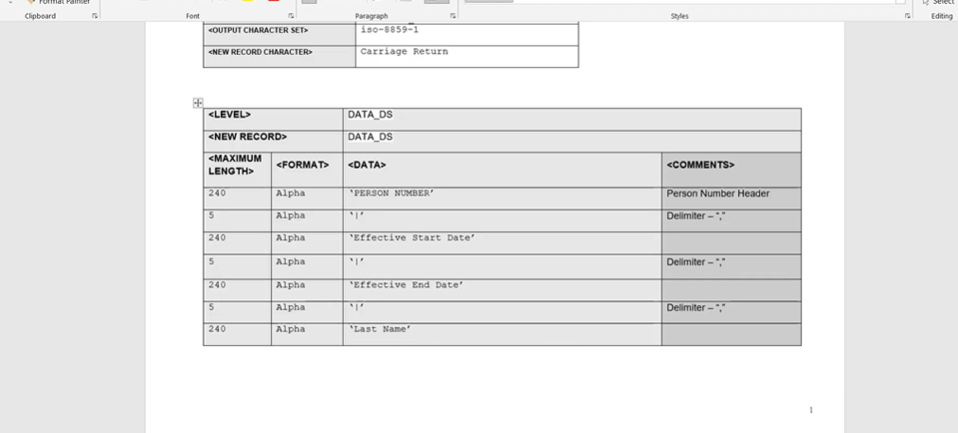

Extension will be rtf but this template is ETEXT.

Go to structure and find the tag names then paste it under data section(in header section we can give any name to column). Save it.

Click on create report – give link of data model – upload etext template – save the report –

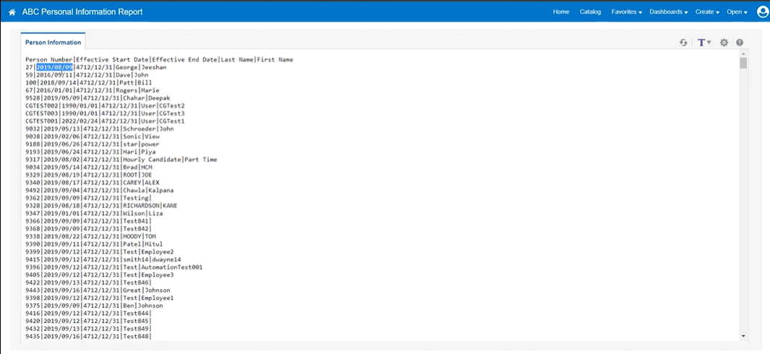

CLASS-32:

Excel template – in RTF template, we can only use upto 63 columns then in that case we use excel template.

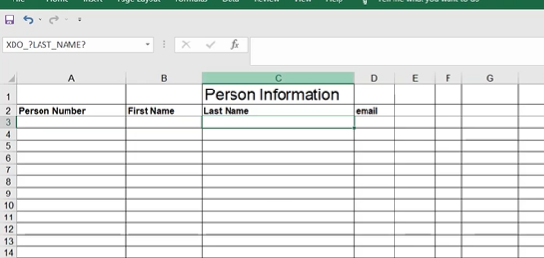

Under column name – we have row where we need to use XML tag names.

Another sheet consists of metadata – XDO_METADATA

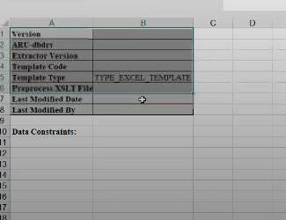

🡪Click on formulas – name manager – pop up with all column names.(group name which we have to maintain). Select all columns and paste group name. Also provide xml tags under each column

🡪while saving choose xls format. Created data model – create report – give datamodel link – choose xls template while uploading – save – view report

WIZARD Template –

Go to data model – click on edit – create report –

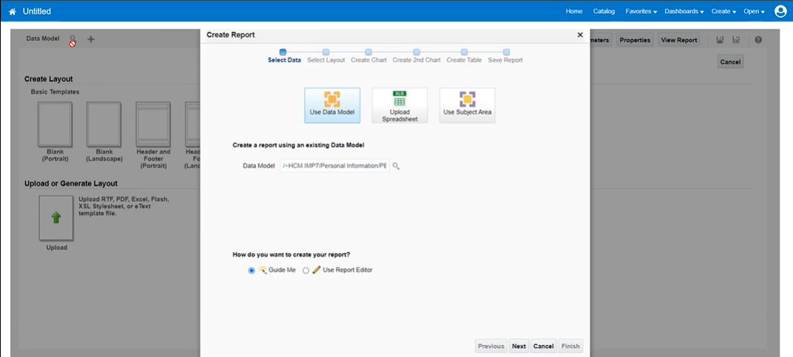

Choose next this time.

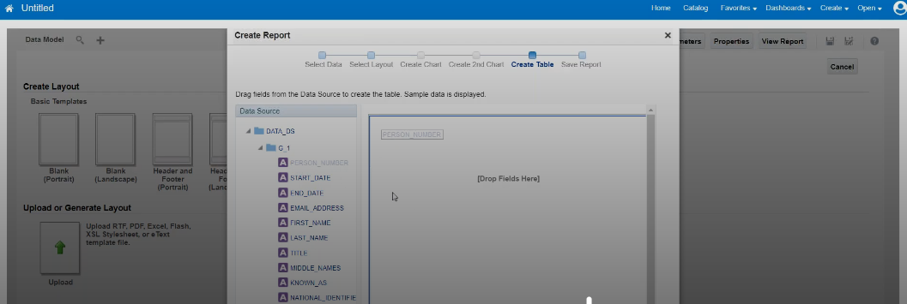

Drag and drop required columns. Click on finish – save report

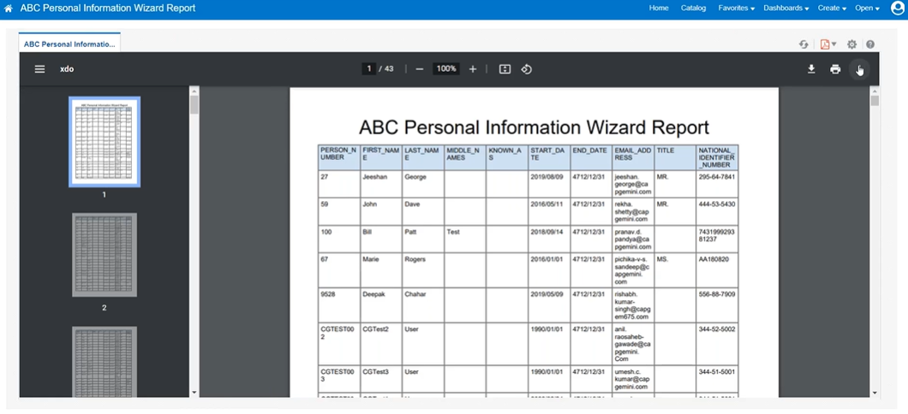

We can also edit the template manually.

🡪How to migrate one instance to another(env test to prod)

Migrate data model and report – click on archive – it will be downloaded –

Go to prod instance – shared folder – unarchive(browse and choose data model & similarly report) – click on edit report – choose datamodel- view report.

Alerts:

We have an option to schedule and send report to an specific persons email address.

Click on open report – click on actions – click on schedule option

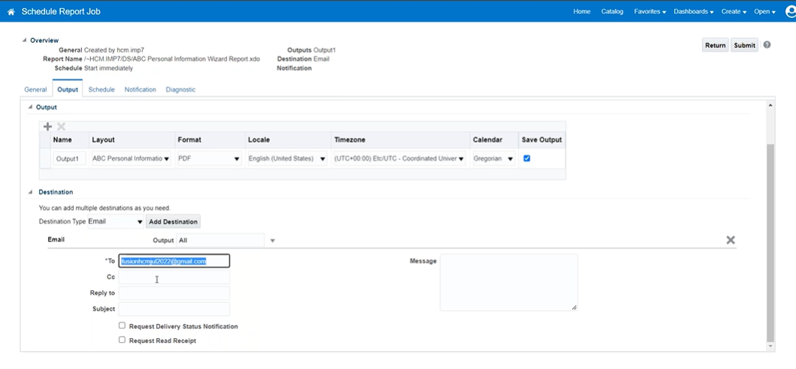

Under schedule tab – we can provide frequency.

CLASS-33:

OTBI reports works based on the user roles. It provides security. Whereas BI report doesn’t have security.

OTBI reports have subject areas – whereas BI report we need to write sql query and create template.

Under Tools work area – reports and analytics – click on create (choose analysis) – select subject areas (workforce management – worker assignment real time).

CLASS-34:

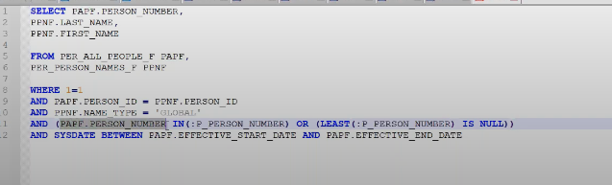

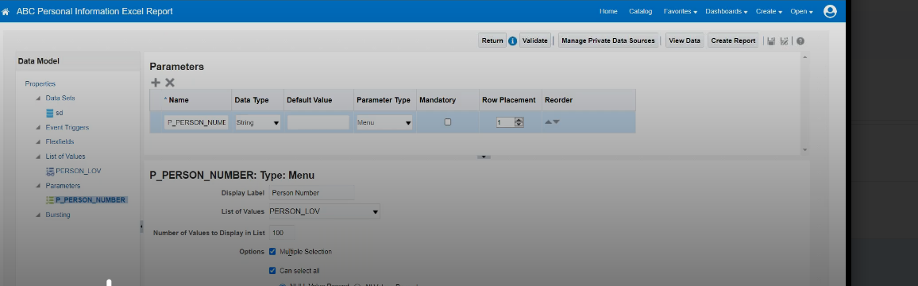

For multiple selection of parameters, we have to choose options as multiple selection as shown in pic.

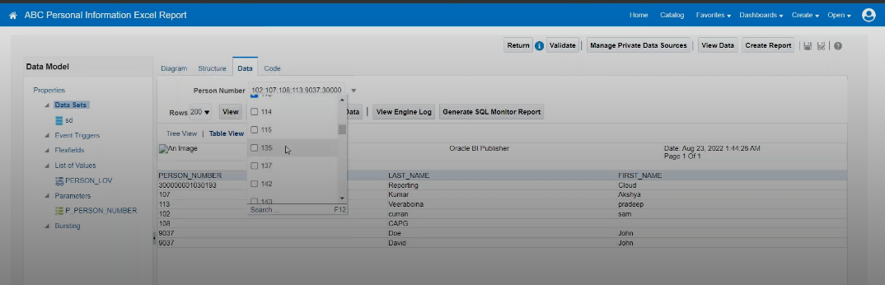

Data Migration from legacy to fusion:

1. HDL – load bulk data
2. SDL – will no support huge data.
3. Manual – very less data

🡪HDL:

For workforce structure:

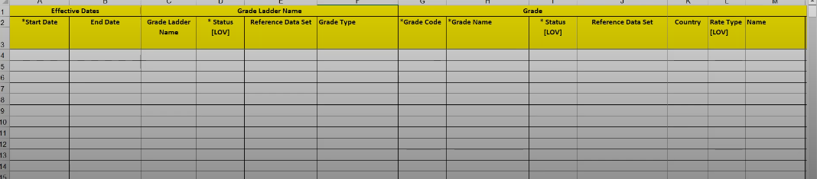

To load the data we have:

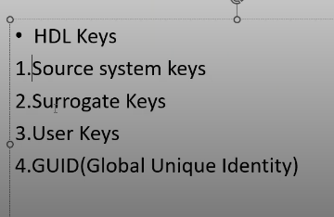

1. Whenever we are loading fresh data into the system, we use Source system keys.
2. When data is loaded already and if we want to update/correct the data we use Surrogate keys.
3. User keys – if we want to load usernames then we need user keys.

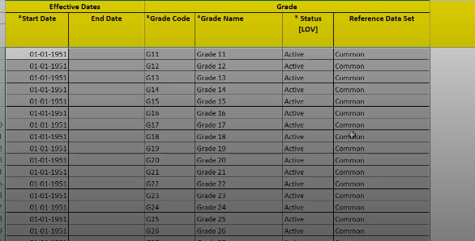

Client has given the data in excel and we need to load it into the system.

My client group – data exchange – under HDL(choose view business objects) – search with grade – grade.dat is template name

Download the template Grade.dat



Take mandatory columns

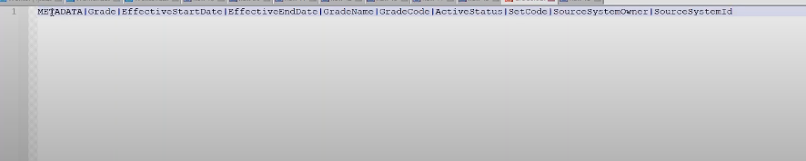

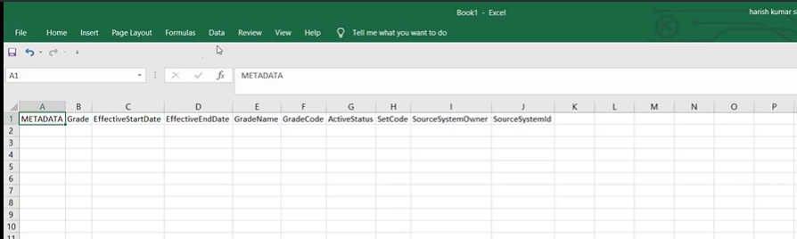

Click on data – text to columns – choose delimited – provide | symbol in others check box

* To create source system owner: setup and maintenance – manage common lookups – create source system owner

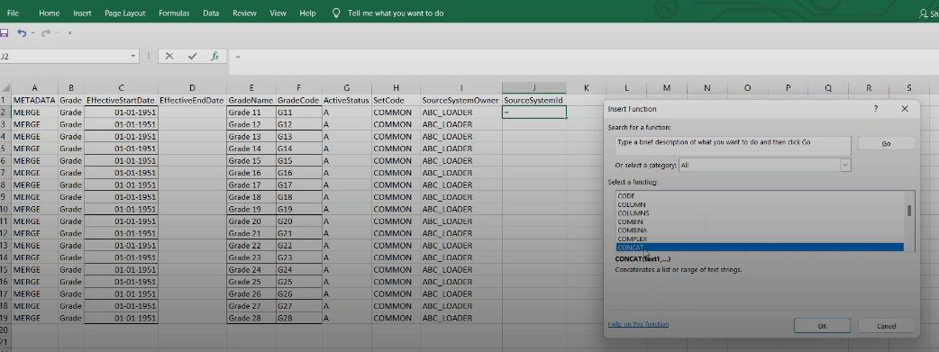

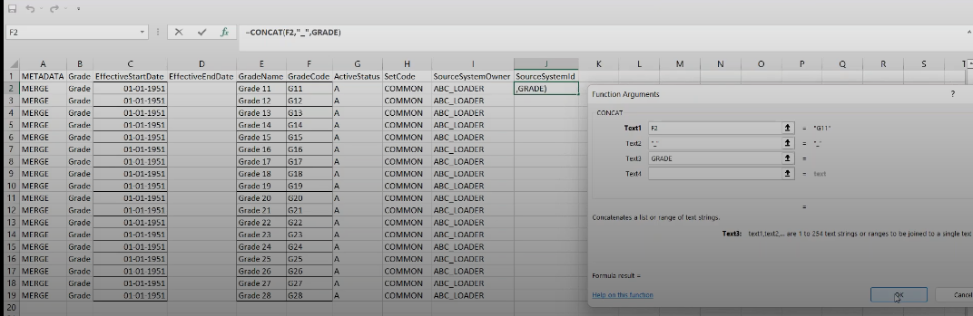

For effective date, right click on column name – format cells – custom – yy/mm/dd(hdl supports this format)

Now paste the data in dat file

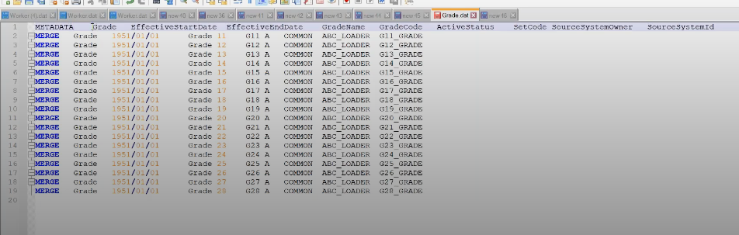

Replace gap with | symbol

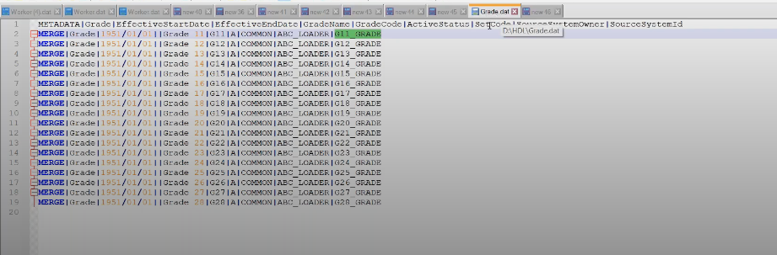

Save the file with grade.dat and zip this file

Go to Myclient group-data exchange- import and load the data

Click on import file

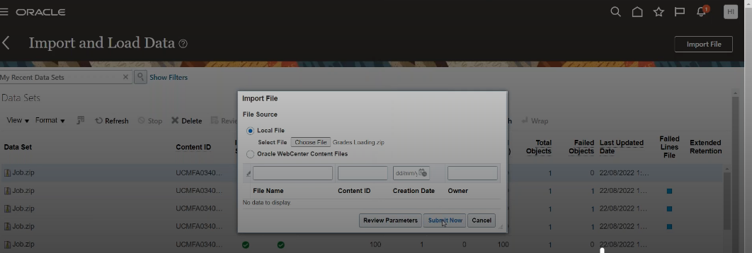

We get departments, locations, jobs, job family, grades, worker information.

CLASS-35:

Learn to Load job family

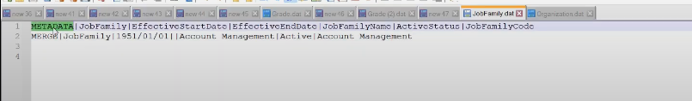

Myclient group – data exchange – view business object – search for job family – download jobfamily.dat file

Get required columns, sourcesystemowner & source system id(based on code)

Go to excel - paste it – click on data - text to column -popup (others | pipe symbol)

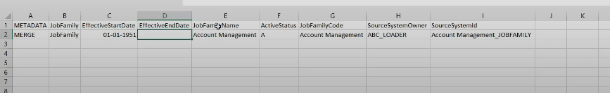

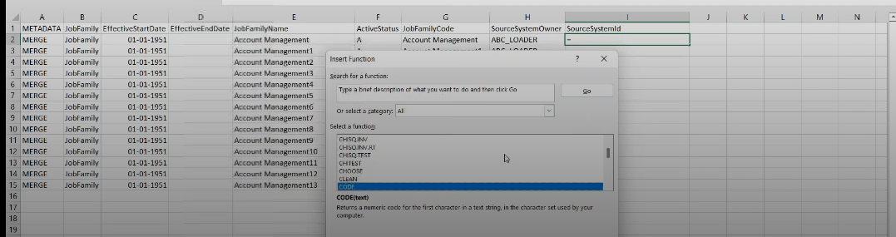

Apply sourcesystemId using functions in excel – format date into yy/mm/dd 🡪right click on column - format cells –

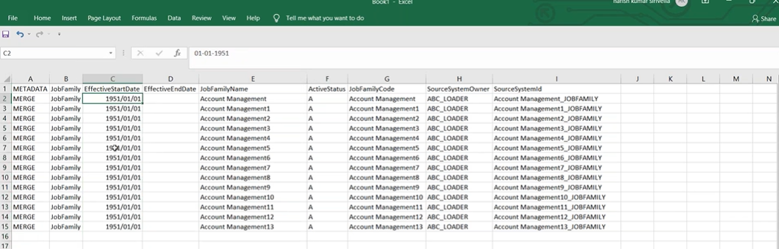

Paste it in jobfamily.dat file – replace space with pipe symbol

Save the file and zip it.

Click on import and load the data – import file – select file and submit

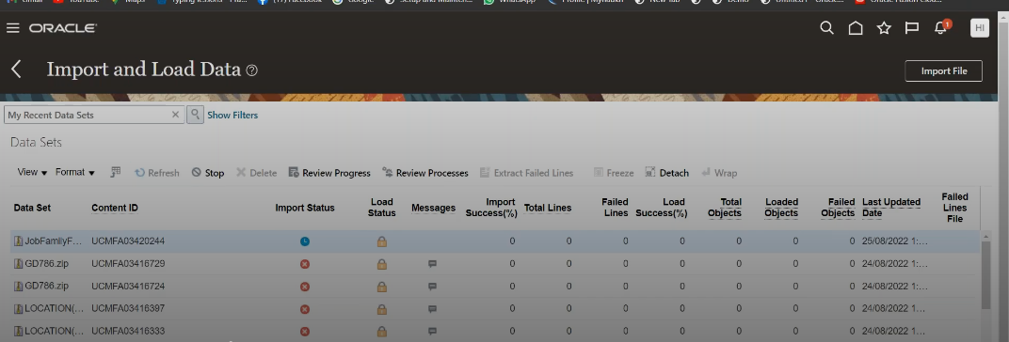

Click on refresh to check status.

We can also delete all the job family loaded into system by replacing MERGE with DELETE in dat file

🡪If we are not loading the data but updating it then we have to not give the sourcesystemID instead use the existing code which are called user keys.

Lets say we have job family loaded by someone else and we have a requirement to change the status as active to inactive.

To update/correct we have to use user keys/ surrogate keys.

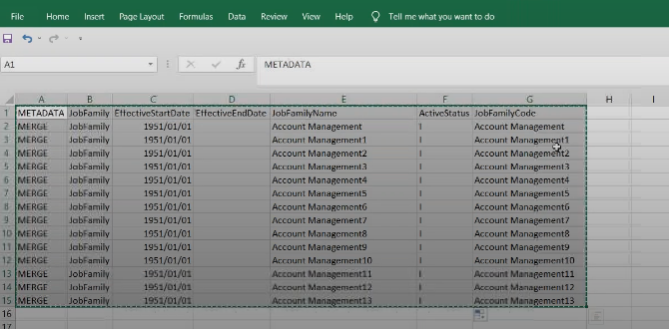

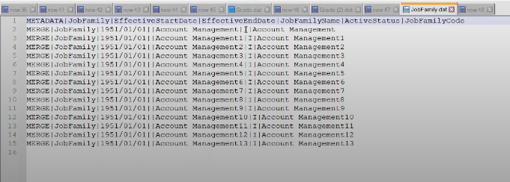

Save dat file – upload it (now we have used user keys)

🡪Surrogate keys Usage: by using ID and we have to take it from the backend.

Go to data model and give query

Select * from per_job_family_f_tl

where job_family_name=Account_management

You will get the job family ID.

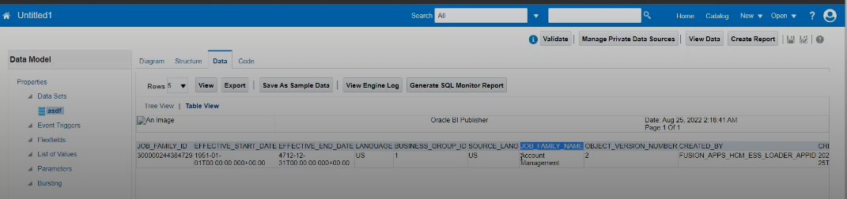

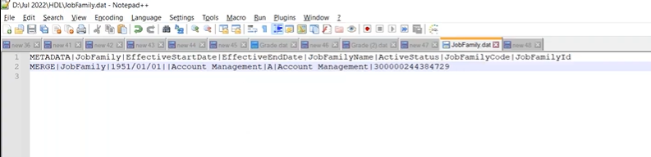

Save the file and upload

🡪Same way we can load the jobs

CLASS-36:

🡪Load departments

We have organization.dat file to load departments.

We will have 2 metadata. One is organization and another is org unit classification.

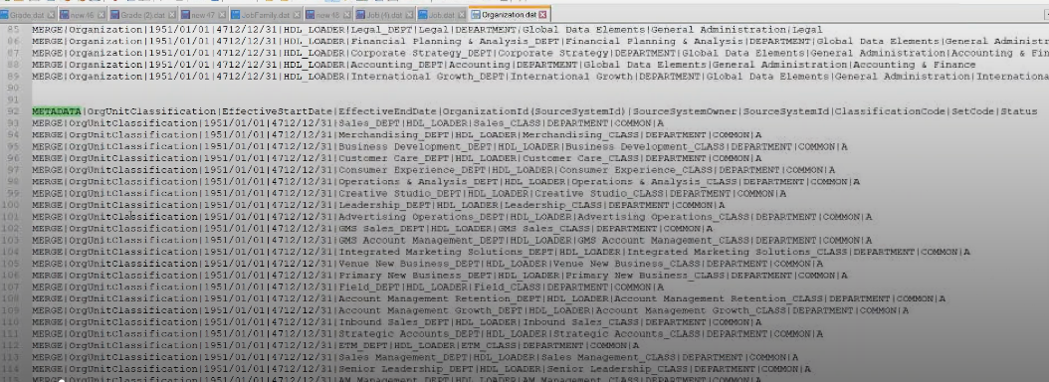

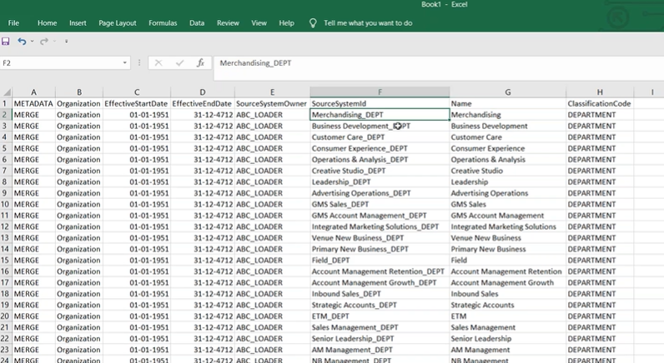

Same way we can load location data

🡪Let’s discuss on how to load employee into the application.

Download worker.dat file.

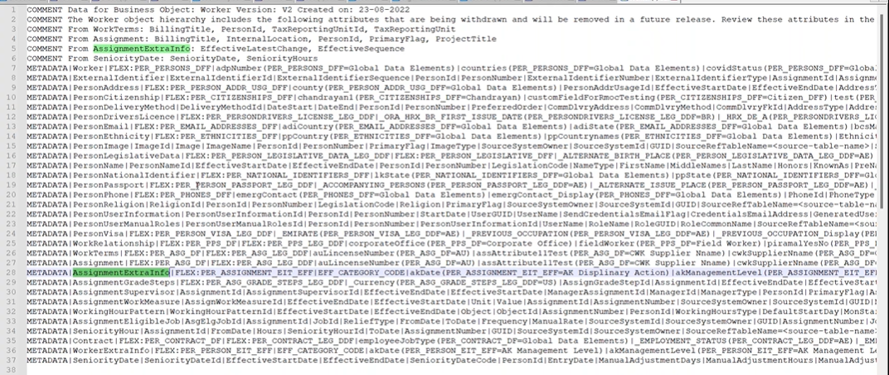

We need to maintain worker, personName, workrelationship, work terms, assignment metadata.

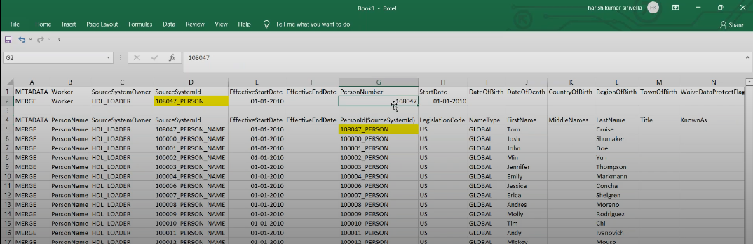

CLASS-37:

Load addresses.

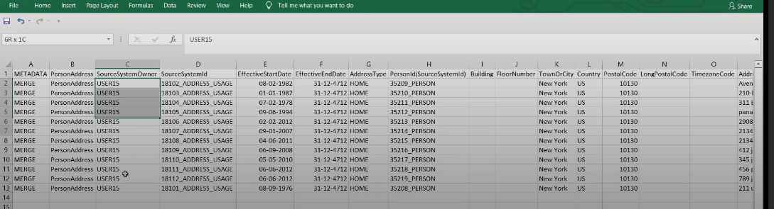

Person address, person email, ethnicity,business entity(legislation)

🡪Using HSDL:

Data exchange – under SDL – Spreadsheet template

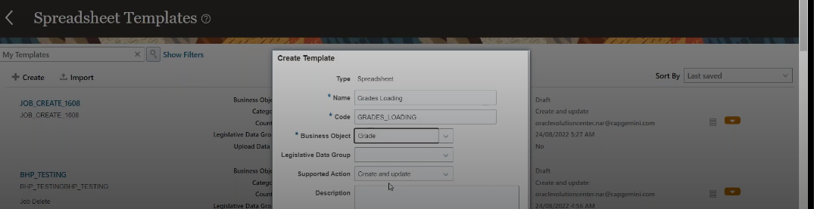

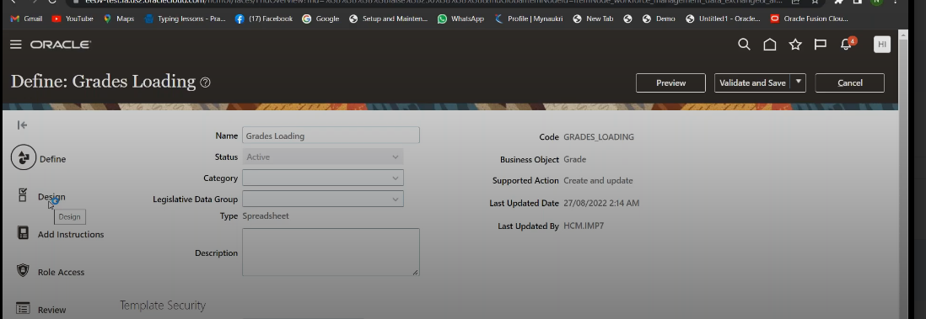

Make it as active and go to design. Select required columns

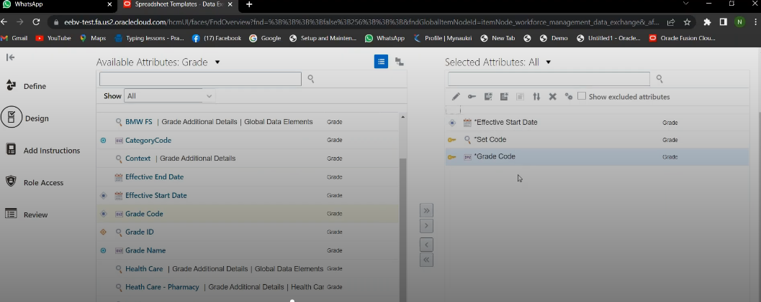

Click on validate and save, Now template is created.

Select template and click on preview. It gets downloaded.

Before that we need desktop Integration software.

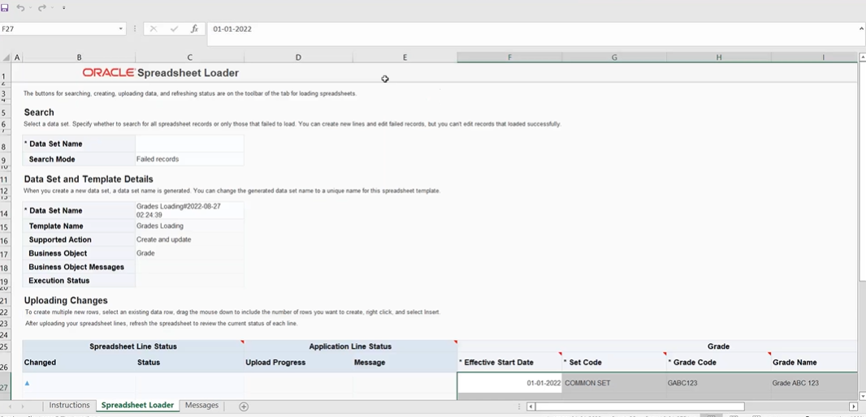

Prepare the data and upload.

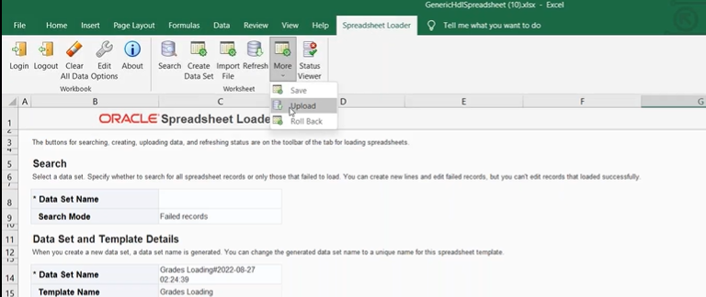

Click on refresh.

CLASS-38:

HCM extracts: We can extract data from fusion application using BI publisher reports.

🡪difference between bi reports and hcm extracts.

BI publisher reports will give full file always. Whereas HCM extracts will give changes only data.

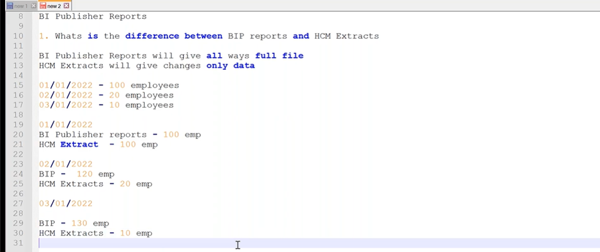

My client group – data exchange – Under HCM extracts – Extract definitions – click on create button

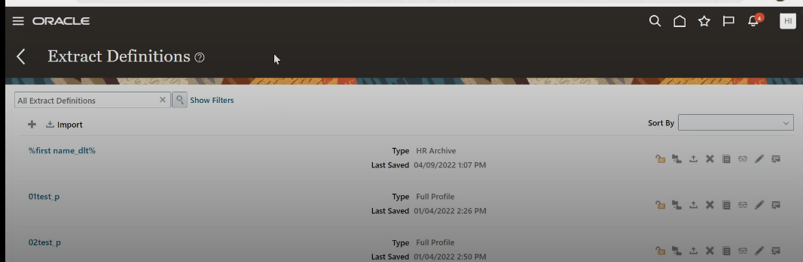

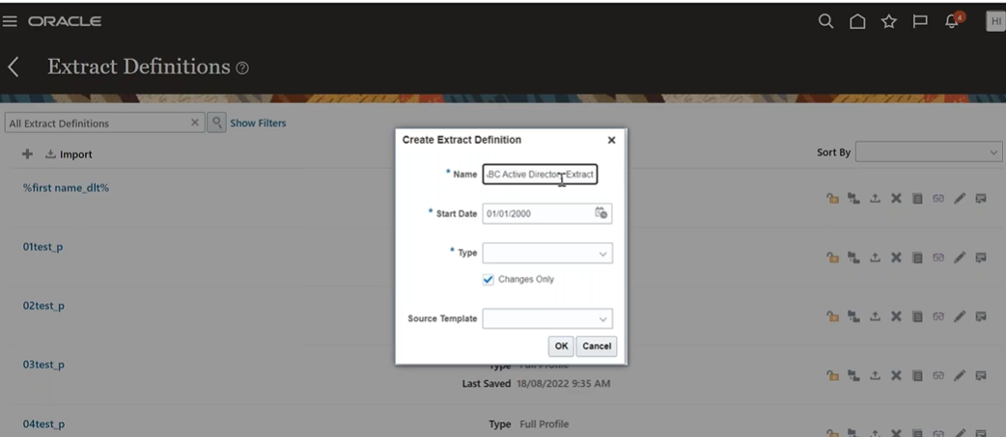

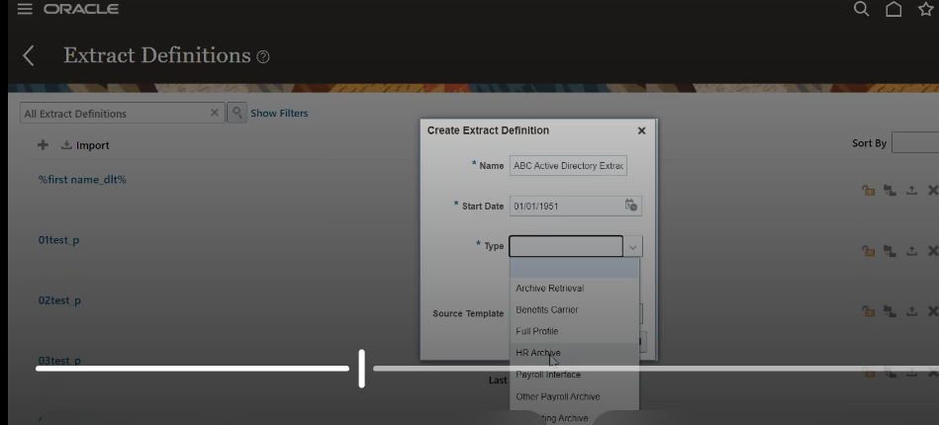

We mostly use HR archive, payroll interface, full profile

🡪HR archive – without considering payroll data

Payroll interface – consider payroll relationship

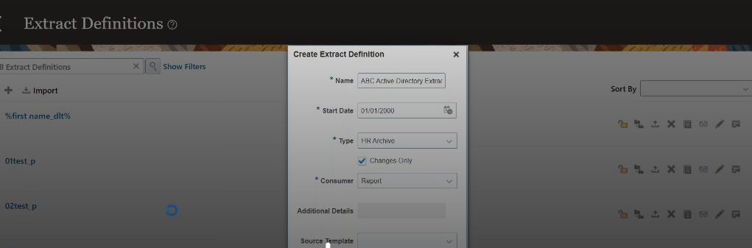

Save and close.

Search for the extract name which is created – click on edit button

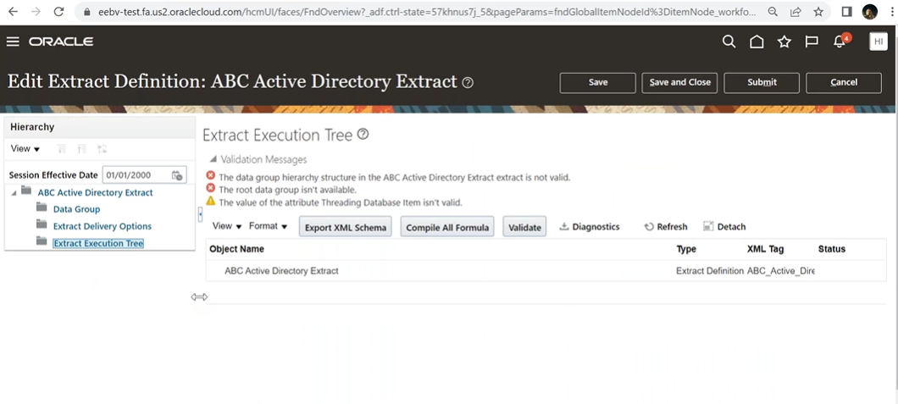

Choose data group -create –

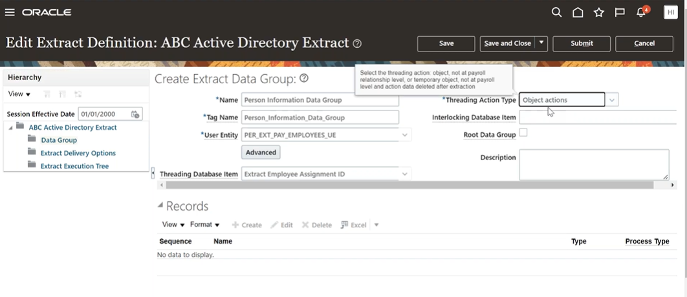

We have multiple user entities for all modules.

Now let’s choose PER_EXT_PAY_EMPLOYEE_UE

Threading database item – to choose changes only data.

Save and close.

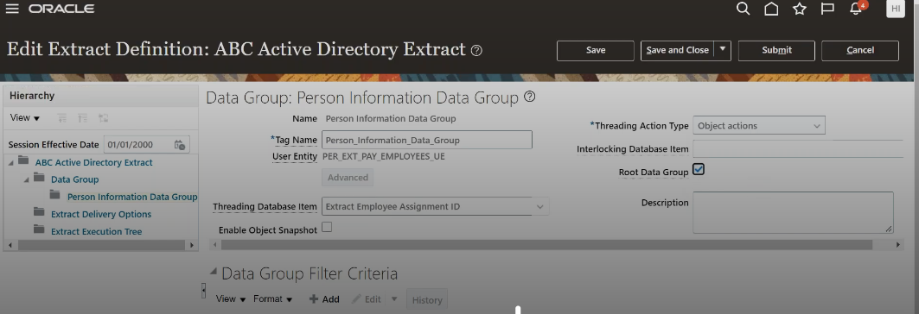

Enable root data group.

We need to create records.

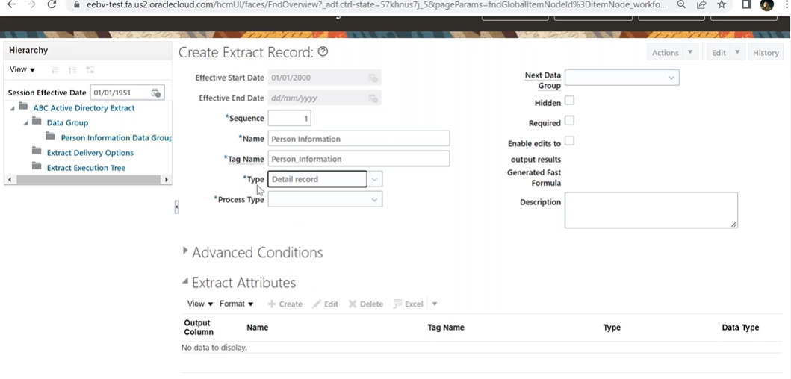

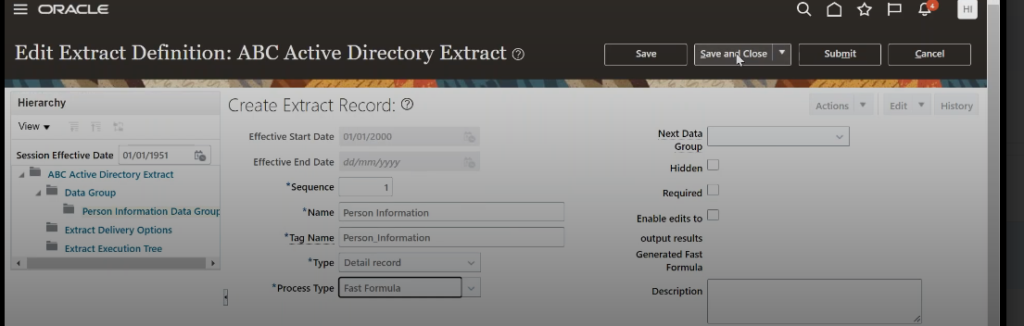

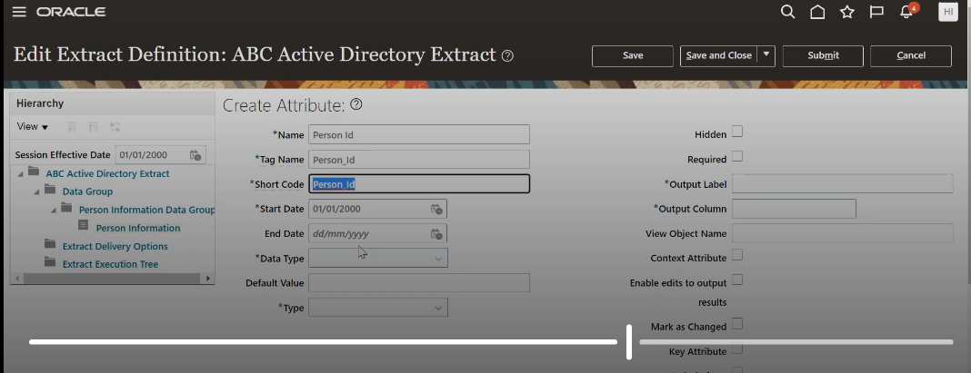

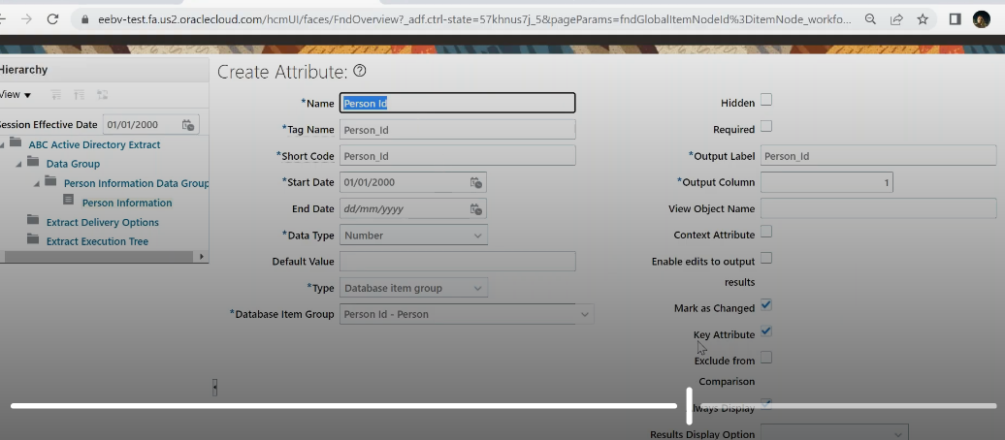

First we have to take one key attribute as primary key i.e, person_id.

Likewise create all the attributes. – person number, person first name, last name, --department, job, grade, location (assignment grade for db item group etc)

CLASS-39:

Once we define hcm extracts and create attributes.

Now we have to create BI publisher report to get the result.

Tools – reports and analytics – browse catalog – we can use seeded data model(navigate to shared folders –human capital management – payroll – datamodels – globalreportsdatamodel(especially created for hcm extracts)

Click on more – and select copy – save it in the place where we have regular custom reports.

Paste it here

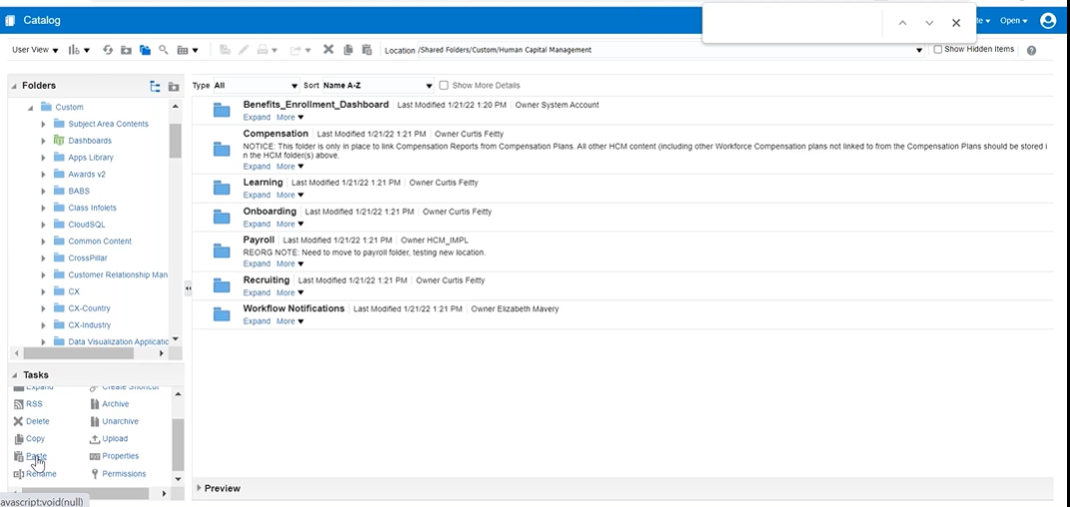

Rename the data model, get the etext template sample – ensure you match tag names.

Click on create report – attach datamodel using search – upload etext template – save the report

Now map this report to extract- go to extract definition – option called extract delivery options – click + add –

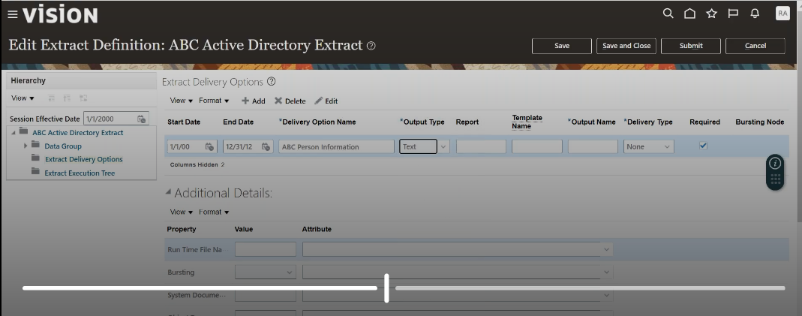

Under report we have to give the report path – custom/Humancapitalmanagement/abc_person_information.xdo

Also provide template name and output file name (our wish).

Delivery Type(choose none) and under additional details we have to provide value for locale as en-US. Save and Close

🡪There is another folder called Extract execution tree

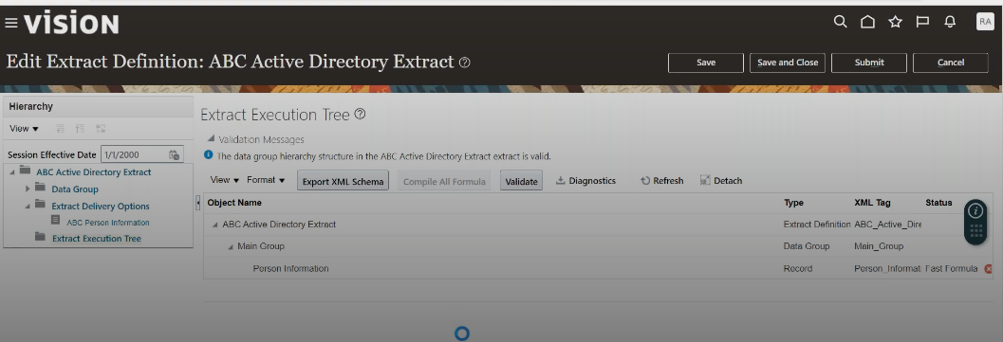

Click on compile all formula – refresh – you get green tick under status.click on Submit button

🡪Now as we run the BI report, similarly we have to submit extract

My client group – payroll – under flow submission and results – click on Submit a Flow – choose extract name -

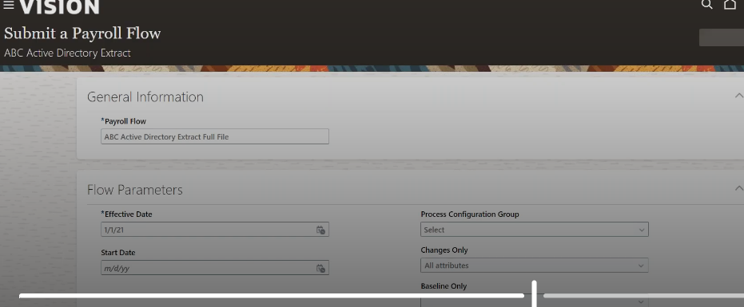

Submit and refresh.

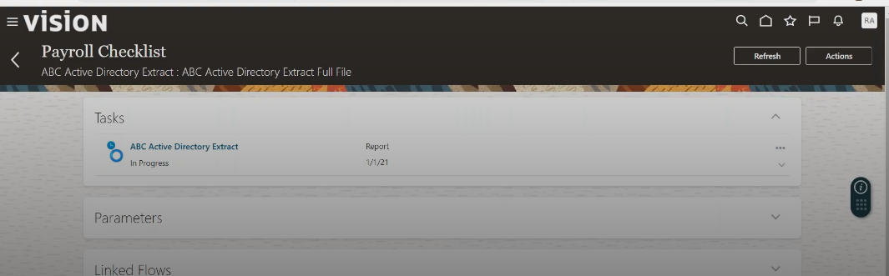

Go to view – actions – export - download output (gets txt format)

🡪for our verification purpose, we can see the report

go back to reports and analytics – view report – provide flow instance name.

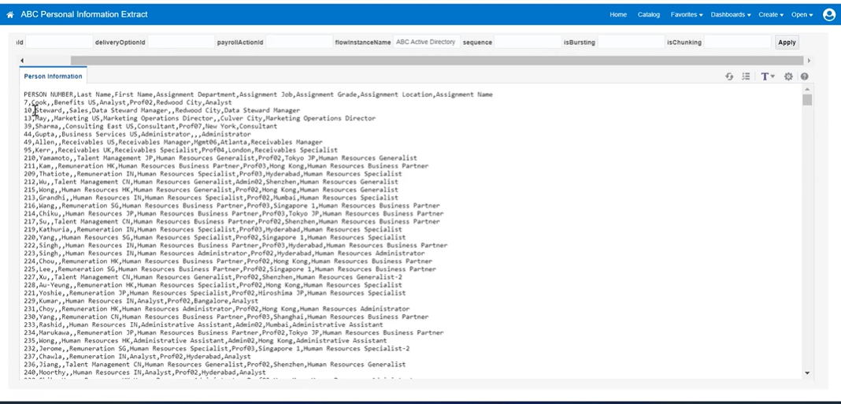

First name is missing in the report – check etext template under header tag name was wrong.

🡪”view flows” to check.

🡪we get the report with all the employee info who are joined 1/1/2021 for first time it will all employees details. Now we need to submit extract with changes only.

Go to my client group – payroll – submit a flow – choose extract –

We only have to provide incremental date only for the next time.

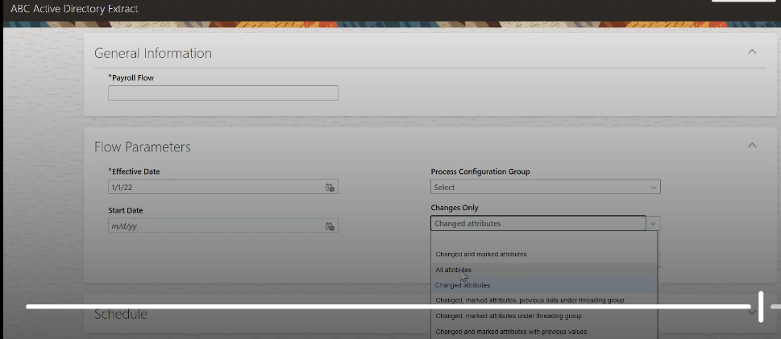

First time we chose all attributes and then next we have to choose changed attributes. Submit

CLASS-40: restrict the records and where we can write the criteria to restrict it at extract level

🡪last time we fetched all worker types data. But if we want to fetch only employee data.

My client group – data exchange – extract definitions – choose extract – click on edit –

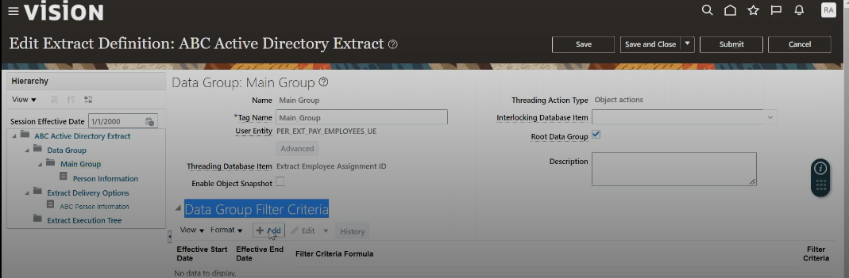

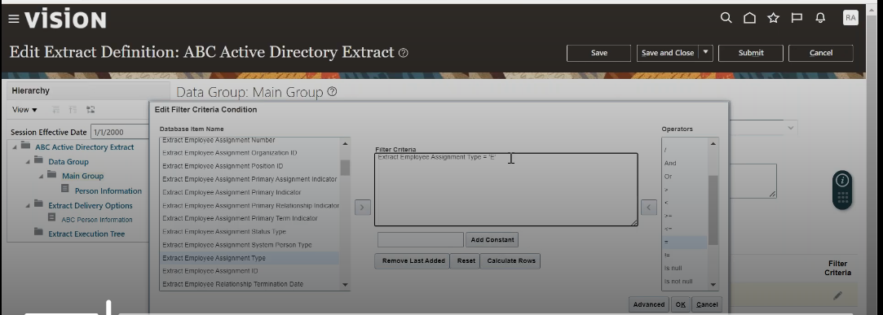

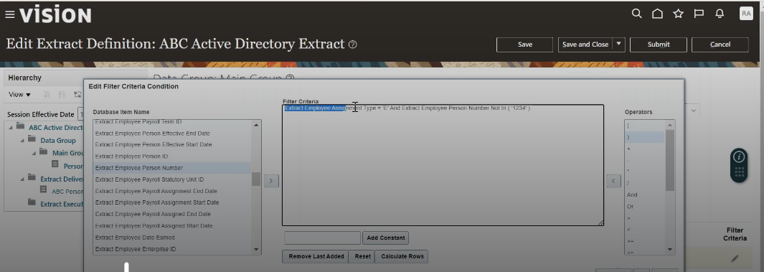

After adding filters – save – go to extract execution tree – compile all formula

If we add another column in extract definition then we have to add the same in template.

🡪Fast formulae: If there is no database item like no column existing then we use fast formulae

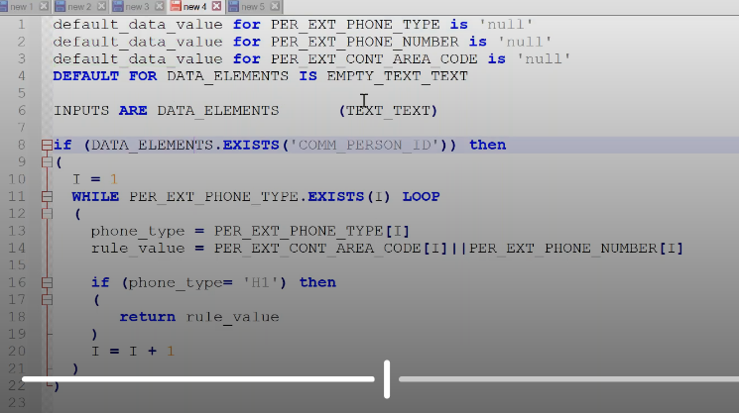

To define fast formulae, go to setup and maintenance, search for fast formula task.

Click on create

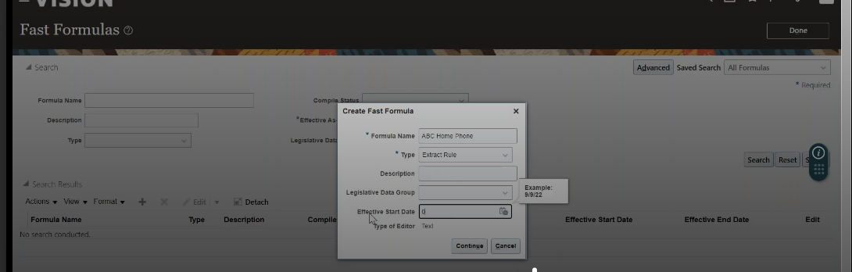

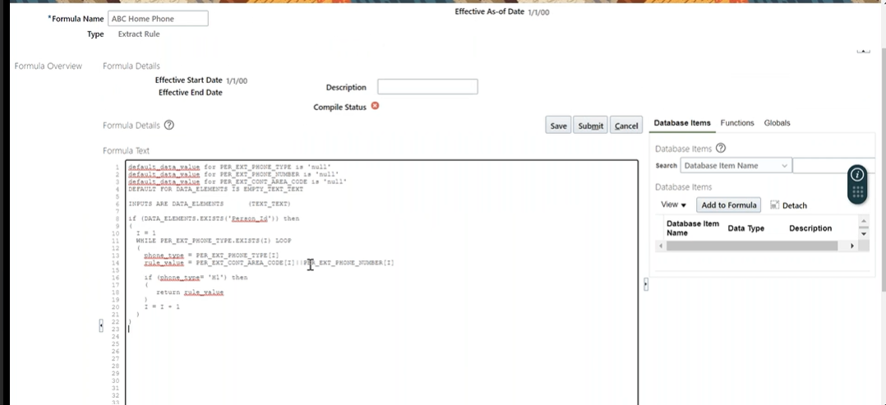

Save and submit. Click compile and refresh.

To call fast formula – go to extract – add attribute –

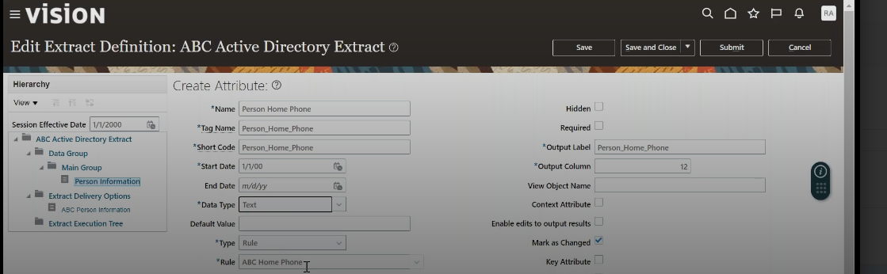

Save and close.

Extract execution tree – compile fast formula – save and close – submit

We have to update RTF template

Report and analytics – edit report – open downloaded template – add header called home phone and its xml tag name

Upload the template by deleting existing.

Myclient group – payroll – submit a flow – choose extract –

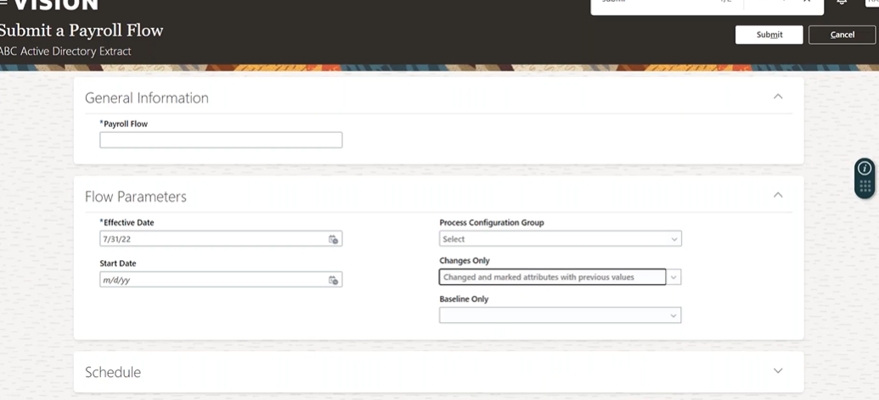

Choose changes only as changes and marked attributes with previous values. Once this is submitted. Go to extract report and provide flowname. Click on apply. See the output